**CURRICULUM VITAE**

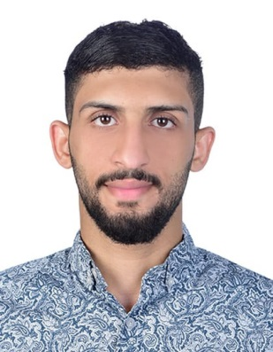

**PERSONAL INFORMATION**

Name: HUSSAIN ALI SAEED CPR: 971006571

Date of Birth: 24/10/1997 Place of Birth: JIDHUFS

Nationality: Bahraini Sex: Male

Marital status: Single

**CONTACT INFORMATION**

Address: H: 1542 – R: 2725 — B: 527 Saar

Cell phone: +973 66919295 -- +973 33935399

E-mail: halradhi97@gmail.com

**EDUCATION**

JIDHUFS Technical secondary school with GPA of 87.9

**EXPERIENCE**

Working in carridge as driver

Working in security solution as security guard

**LANGUAGES**

Arabic, reading and writing.

English, reading and writing.

**ADITIONAL SKILLS**

Ability to manage and develop myself, Fast improving own learning and performance, Effective time management, Ability to work with others, Building up good working relationship.

**INTERESTS**

Playing football and practice sports.